**phoenix建表列名重复，导致无法删除表格和修改，插入数据**

**操作过程：**

第一步删除phoenix中[系统](https://www.2cto.com/os/)的表格信息，主要为SYSTEM.CATALOG，第二步删除Hbase中的表格信息。

**操作步骤：**

(1)查询phoenix系统表

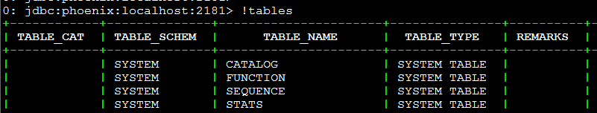

SYSTEM.CATALOG 内容是所有表格的信息，系统表和自建表

SYSTEM.FUNCTION 内容是所有函数信息，系统函数和自定义函数

SYSTEM.SEQUENCE 我也不知道

SYSTEM.STATS 内容是所有表格的最后状态信息

(2)查询SYSTEM.CATALOG表结构

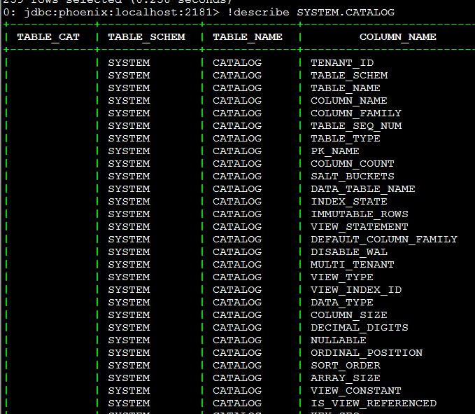

(3)要删除的表格

DELETE from SYSTEM.CATALOG where TABLE_NAME = ‘USER_DETAILS’;

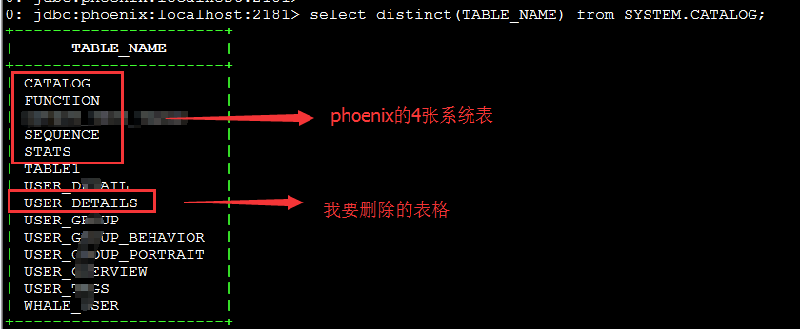

(4)查询SYSTEM.STATS表结构

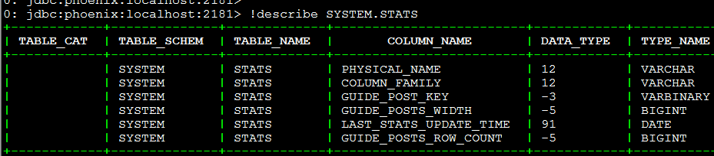

(5)删除Hbase中的表格

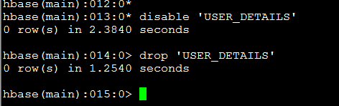

(6)重新建表以及查询

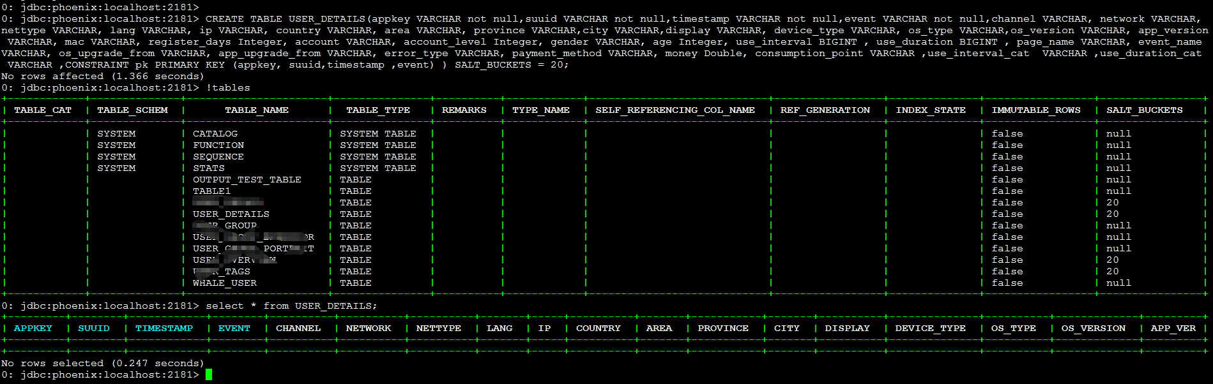

0: jdbc:phoenix:localhost:2181> drop table USER_DETAILS;

16/07/21 14:38:15 WARN ipc.CoprocessorRpcChannel: Call failed on IOException

org.apache.hadoop.hbase.DoNotRetryIOException: org.apache.hadoop.hbase.DoNotRetryIOException: USER_DETAILS: 36

at org.apache.phoenix.util.ServerUtil.createIOException(ServerUtil.java:87)

at org.apache.phoenix.coprocessor.MetaDataEndpointImpl.dropTable(MetaDataEndpointImpl.java:1469)

at org.apache.phoenix.coprocessor.generated.MetaDataProtos$MetaDataService.callMethod(MetaDataProtos.java:11725)

at org.apache.hadoop.hbase.regionserver.HRegion.execService(HRegion.java:7796)

at org.apache.hadoop.hbase.regionserver.RSRpcServices.execServiceOnRegion(RSRpcServices.java:1988)

at org.apache.hadoop.hbase.regionserver.RSRpcServices.execService(RSRpcServices.java:1970)

at org.apache.hadoop.hbase.protobuf.generated.ClientProtos$ClientService$2.callBlockingMethod(ClientProtos.java:33652)

at org.apache.hadoop.hbase.ipc.RpcServer.call(RpcServer.java:2170)

at org.apache.hadoop.hbase.ipc.CallRunner.run(CallRunner.java:109)

at org.apache.hadoop.hbase.ipc.RpcExecutor.consumerLoop(RpcExecutor.java:133)

at org.apache.hadoop.hbase.ipc.RpcExecutor$1.run(RpcExecutor.java:108)

at java.lang.Thread.run(Thread.java:745)

Caused by: java.lang.ArrayIndexOutOfBoundsException: 36

at org.apache.phoenix.schema.PTableImpl.init(PTableImpl.java:403)

at org.apache.phoenix.schema.PTableImpl.(PTableImpl.java:315)

at org.apache.phoenix.schema.PTableImpl.makePTable(PTableImpl.java:303)